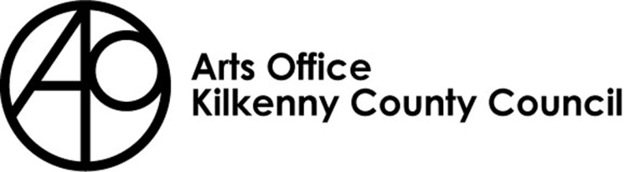

KILKENNY POETRY BROADSHEET 2021
ISSUE 21 - APPLICATION FORM

Kilkenny County Council Arts Office is inviting submissions from poets born or based in Kilkenny City and County for the 21st Issue of Kilkenny Poetry Broadsheet.

We are delighted to announce that Jessica Traynor will be editor of this year’s Broadsheet.
Jessica is a poet, dramaturg, librettist and creative writing teacher. Her debut collection, Liffey Swim (Dedalus Press, 2014), was shortlisted for the Strong/Shine Award. Her second collection, The Quick, was a 2019 Irish Times poetry choice. In 2019, she co-edited Correspondences: an anthology to call for an end to direct provision with actor Stephen Rea, bringing together asylum seekers in Ireland’s direct provision system with Irish writers. The book was a best-seller, with all proceeds going to MASI (Movement of Asylum Seekers in Ireland).

Current projects include a commission from Offaly County Council and The Department of Housing, Planning and Local Government to write a poetic history of the town of Banagher. The resulting pamphlet, A Place of Pointed Stones, is forthcoming in 2021.

Rules of Submission

Submissions can be in English or Irish

Submissions must be the work of the entrant (no third party submissions)

Entrants must be 18 years of age or over

Limit of TWO entries per person.

Submissions MUST be typed and no longer than 30 lines

Work MUST NOT be signed

Entrants must be born or based in Kilkenny City or County

Submissions may have been published previously

Details of any such publication must be included with your application

The editor’s selection of published and shortlisted poems is final
- To be accepted for publication the editor may suggest edits to your poem/s for your consideration
- There is no submission fee but entries will not be returned

Please send submissions preferably in digital format (Microsoft Word) by email to deirdre.southey@kilkennycoco.ie . Hardcopy applications can still be submitted to: Kilkenny Arts Office, Johns Green House, Johns Green, Kilkenny.

The closing date for submissions: 4pm Thursday 1st April

Further information 056 7794547

KILKENNY POETRY BROADSHEET ISSUE 21

APPLICATION FORM

Name in full (Block letters)

Postal address

________________________________________
________________________________________
________________________________________

Tel. Number

Email Address

Title of Work(s)

- ___________________________________
- __________________________________________

Have you had work(s) (those submitted here or otherwise)
published previously?
Yes No

_______________________________________________
_______________________________________________
_______________________________________________
_______________________________________________
_______________________________________________
_______________________________________________

If so, please give brief details

I consent to the holding and processing of my personal data for the purposes of this application only and I understand that it will not be used for any other purposes.
I confirm that I am 18 years of age or over and I was born or resident in Kilkenny.

Signed: ____________________________ Date:________________________________

